**CYBER SECURITY INTERNSHIP IN ELEVATE LABS**

**Task 1: Scan Your Local Network for Open Ports**

Find out the local IP address

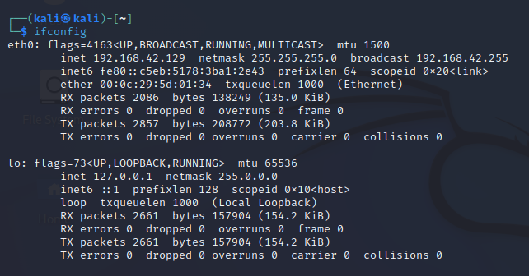

Run: nmap -sS 192.168.1.0/24 to perform TCP SYN scan and Note down IP addresses and open ports found.

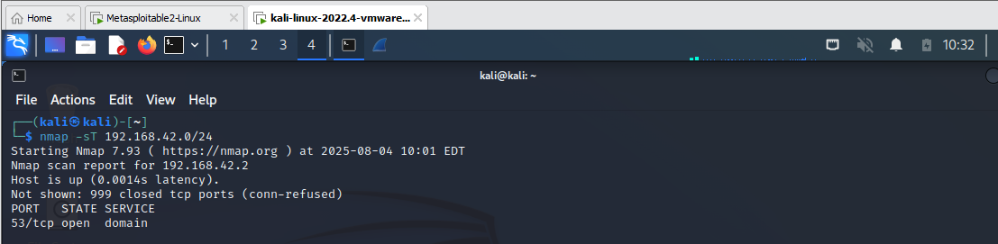

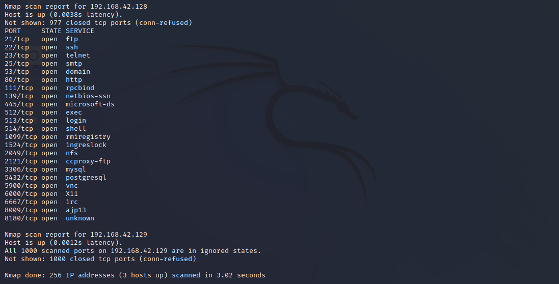

Optionally analyze packet capture with Wireshark and Research common services running on those ports.

